AS PHOTOGRAPHY
SUMMER HOMEWORK
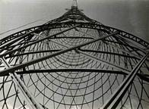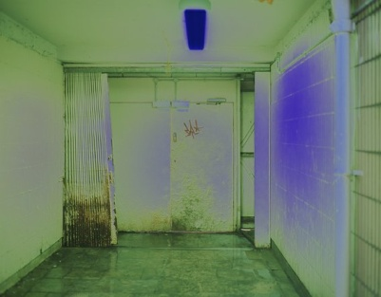

Choose one of the following themes;
MOVEMENT ABSTRACT DESIGN COLOUR

Select a photographer who you think uses your chosen theme in their photography. For inspiration go to:
http://charterphotography.weebly.com/artists.html

Respond to your chosen theme and the photographer’s work by taking a minimum of 20 photographs and selecting your 5 most successful.

Be prepared to present and discuss your work.

